Exploring the Relationship Between ADHD Symptomatology and Caffeinated Beverage Consumption: A Meta-Analysis

Abstract:
Although previous literature has identified an association between ADHD symptomatology and stimulant use such as cigarettes and cocaine, as well as an association between ADHD symptomatology and sugary and soft drink consumption, no meta-analysis to date has explored whether an association existed between ADHD symptomatology and caffeinated beverage consumption. To explore this relationship and potential moderators, a meta-regression was conducted. The meta-analysis identified a significant association between ADHD symptomatology and caffeinated beverage intake with a correlational effect size of 0.1198. Energy drink consumption was shown to have a significant moderating effect on this association. Future studies should explore the potential mechanism behind the moderating effect of energy drink consumption on this relationship.
Introduction:
Attention-deficit/hyperactivity disorder (ADHD) is a neurodevelopmental disorder that is characterized by challenges with attentional control, impulsivity and/or hyperactivity, with a global prevalence between 2% and 7%. (Reichenberg, 2016; Sayal, 2018). In children with ADHD, behavioral challenges arise from a dysregulation of motivation and reward systems and attention and executive control challenges arise from an inability to effectively activate the prefrontal cortex area of the brain when faced with to be attentive or exhibit executive control (Vazquez, 2022). There is a large body of literature highlighting the effectiveness of stimulant prescription medications in managing ADHD symptoms in children and adults (Faraone, 2010; Mészáros, 2009). Although effective at managing the symptoms of ADHD for many individuals, there is also the reality of a number of side effects that are deemed undesirable for patients (Nanda, 2023). Far fewer studies have explored other forms of stimulant use amongst individuals with ADHD. A recent meta-analysis by Oliva (2021) found an estimated prevalence of cocaine use amongst adults with ADHD of 26%. Kollins (2005) highlighted a significant association between self-reported ADHD symptoms and adult smoking. A significant association between ADHD symptomatology and sugary beverage consumption was reported in a recent meta-analysis by Farsad-Naeimi (2020). A recent meta-analysis Vázquez (2022) indicated that caffeine treatment improves ADHD symptoms in animal models. This begs the question of whether or not individuals with ADHD are self-medicating via the consumption of caffeinated beverages. However, there is not yet a clear consensus as demonstrated through a meta-analysis as to whether or not a significant association between ADHD symptomatology and caffeinated beverage consumption exists in humans, which is an important first step in investigating the potential of medication of ADHD using caffeine. The goal of this meta-analysis was to explore the potential cross-sectional association between ADHD symptomatology and caffeinated beverage consumption, while exploring whether caffeinated beverage type, age, gender, and geographic moderated this possible relationship, with an understanding that a positive association between caffeinated beverage consumption and ADHD symptomatology may indicate the possibility of self-medication of ADHD symptoms with caffeine in the population or the exacerbation of ADHD symptoms by consuming caffeinated beverages. Given the cross-sectional nature of the studies included in the meta-analysis, the directionality of a potential significant association cannot be determined but would lay the groundwork for future research.
Method:
To explore cross-sectional associations between ADHD symptomatology and caffeinated beverage consumption, a literature search was conducted, gathering observational studies that reported an effect size between ADHD symptoms and caffeinated beverage consumption. The
databases included in the literature search included ERIC, Medline, ProQuest, PsycInfo, and PubMed. Search terms were (ADHD OR adhd OR attention deficit disorder with hyperactivity OR syndrome hyperkinetic OR hyperkinetic syndrome OR hyperactivity disorder OR hyperactive child syndrome OR childhood hyperkinetic syndrome OR attention deficit hyperactivity disorders OR attention deficit hyperactivity disorder OR attention deficit hyperactivity disorder OR adhd OR overactive child syndrome OR attention deficit hyperkinetic disorder OR hyperkinetic disorder OR attention deficit disorder hyperactivity OR child attention deficit disorder OR hyperkinetic syndromes OR syndromes hyperkinetic OR hyperkinetic syndrome childhood) AND (caffeine OR caffeinated OR coffee OR tea OR energy drink) with no publication date restrictions. The search and screening process for studies to be included in the final analysis is shown in Figure 1. The literature search returned 658 results, with 413 studies remaining after duplicate removal. These 413 studies were screened at the Title/Abstract level. There were two phases of screening. The first phase of screening was performed on 354 search results that were published before October, 2022. The second phase of screening was performed on 59 search results that were published after October, 2022. During the first phase of screening, the 354 titles/abstracts were randomly divided between two pairs of screeners. To meet inclusion criteria, titles and abstracts were required to be in English, focus on human subjects, be observational/cross-sectional, provide a measure of caffeinated beverage consumption, and provide a measure of ADHD symptomatology. After the title/abstract screening, one of the pairs of screeners had a Cohen’s Kappa interrater reliability of 0.5, with the other pair having a Cohen's Kappa interrater reliability of 0.81. To handle discretions between screening pairs, the alternate pair screened the disagreements. During the second phase of screening, titles and abstracts were screened by the first author of the paper using the same inclusion criteria. 35 articles were included after title/abstract screening, and the full-text articles were searched for. Of the 35 articles, 32 of the full texts were accessible. After screening using the same inclusion criteria at the full-text level, 14 articles were included for analysis, as described in Table 1.

Identification
Screening
Analysis
Studies identified via database searches (N = 658)
Studies remaining after duplicate removal (N = 413)
Studies remaining after title/abstract screening (N = 35)
Studies remaining after full-text retrieval (N = 32)
Studies remaining after full-text screening and included in the final meta-analysis (N = 14)
Figure 1. Flow diagram of study selection process.
Author | Fisher's Z Effect Size | Sample Size | Mean Participant Age (Years) | Proportion of Male Participants | Beverage Type* | Country of Study
James et al., 2015 | 0.13 | 1828 | 15.5 | 1.00 | E, C | Other
James et al., 2015 | 0.18 | 1842 | 15.5 | 0.00 | E, C | Other
Schwartz et al., 2015 | 0.07 | 1649 | 16.5 | 0.33 | E | United States
Narine et al., 2021 | 0.05 | 72 | 15.0 | 0.55 | E | United States
Narine et al., 2021 | 0.03 | 69 | 42.9 | 0.33 | E | United States
Cipollone et al., 2020 | 0.09 | 18913 | 13.0 | 0.14 | E | United States
Cipollone et al., 2020 | 0.05 | 18913 | 14.0 | 0.48 | O | United States
Cipollone et al., 2020 | 0.09 | 18913 | 13.0 | 0.51 | O | United States
Agoston et al., 2022 | 0.02 | 2259 | 15.0 | 0.33 | T, E, C | Other
Cusick et al., 2020 | 0.13 | 302 | 42.9 | 0.14 | T | United States
Cusick et al., 2020 | 0.22 | 302 | 12.4 | 0.55 | T | United States
Cusick et al., 2020 | 0.16 | 302 | 28.7 | 0.88 | T | United States
Rios-Hernandez et al., 2017 | 0.27 | 120 | 28.7 | 0.88 | T | Other
Salvat et al., 2022 | 0.24 | 200 | 28.7 | 0.88 | O | Other
Bae et al., 2019 | 0.12 | 511 | 23.2 | 0.63 | T | Other
Martin et al., 2008 | 0.23 | 132 | 8.3 | 0.72 | T | United States
Galimov, 2021 | 0.05 | 5478 | 34.0 | 0.49 | E | Other
Chamberlain et al., 2015 | 0.21 | 126 | 9.3 | 0.57 | T | United States
Walker et al., 2010 | 0.22 | 448 | 22.9 | 0.50 | T, C | United States
Farber et al., 2024 | 0.04 | 7245 | 15.0 | 0.61 | T | United States
*Beverage Type: T=Total Caffeine, E=Energy Drinks, C=Coffee, O=Other

Table 1. Articles Included In The Analysis
The analysis was done using the metafor, esc, and ggplot packages in The R Project for Statistical Computing. To prepare for downstream analyses, all effect sizes were converted to correlation coefficients using the esc package in R. The correlation coefficients of the studies included in the analysis are presented in Table 1, along with the sample sizes of each study and the standard error. In order to compute meaningful confidence intervals for the pooled correlation effect size, the correlation coefficients were transformed to a normal distribution using the escalc package. The meta-analysis was conducted using the metafor package to assess the pooled effect size between ADHD symptomatology and caffeinated beverage consumption, as well as presenting a p-value and a test for heterogeneity. To assess for studies that were particularly influential in the analysis, an influence test was performed and visualized using the metafor package. A distribution of effect sizes corresponding confidence intervals were visualized with a forest plot using the metafor package. A funnel plot was generated using the ggplot2 package to assess potential publication bias. In a funnel plot, larger studies, which have a smaller standard error, are plotted higher on the y-axis, while smaller studies, which have a larger standard error, are plotted lower on the y-axis. If asymmetry in the funnel plot is present, this is an indication of publication bias. A formal test to assess publication bias was performed using an Egger’s regression test.
To assess potential moderating variables in the relationship between ADHD symptomatology and caffeinated beverage consumption, a meta-regression was performed using the metafor package. The proportion of male participants, mean participant age, type of caffeinated beverage (no specification, coffee, and energy drinks), and geographic location of studies (US or non-US studies), were included in the model separately to assess for moderation effects. Each potential moderator was also visualized with a regression plot using the metafor package. Lastly, to account for effect size dependencies that can arise from multiple effect sizes being reported from the same study, robust variance estimation was performed using the metafor package.
Results:
The meta-analysis, without the inclusion of any potential moderating variables, produced a pooled effect size of 0.1141 with a standard error of 0.0163 and a p-value of <0.0001, indicating a significant and weak positive association between ADHD symptomatology and caffeinated beverage consumption. An I²-value of 92.07% indicates that 92.07% of the variation in effect sizes between studies was due to heterogeneity as opposed to chance. The results of the influence test, as shown in Figure 2, indicate no studies that were particularly influential in the pooled effect size, as influential studies would be presented in red. The individual effect sizes are presented with a forest plot, as shown in Figure 3. The confidence interval of the pooled effect size, labeled RE Model in the forest plot, does not contain zero, indicating that despite variation in between-study effect sizes, the pooled effect size can be assumed to be positive and significant. Viewing the funnel plot, shown in Figure 4, indicates potential asymmetry, with smaller studies tending to report larger effect sizes. This could indicate that smaller studies finding smaller effect sizes are not being reported. A formal test for publication bias, an Egger's Regression Test, was performed. A p-value of 0.0011 indicated that a statistically significant study bias existed.
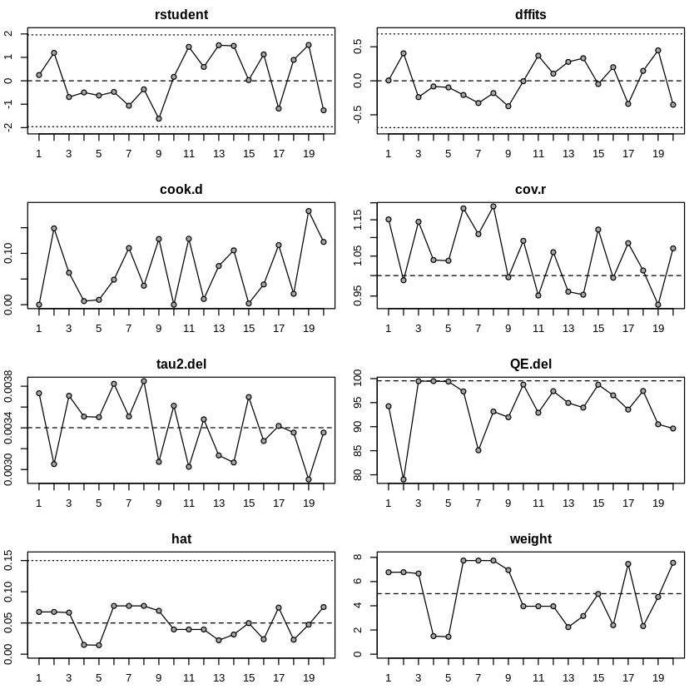
Figure 2. Results of the influence test to assess for influential studies.
To examine the potential moderating effects on study-level variables on the relationship between ADHD symptomatology and caffeinated beverage consumption, independent meta-regressions were performed, and results are presented in Table 2. The coefficient for mean participant age was 0.0003, with a p-value of 0.8673, indicating that participant age did not have a significant moderating effect on the model. Figure 5 shows a regression plot of age included in the study as a moderator. Including the proportion of male participants as a moderating variable in the model resulted in a coefficient of 0.0790 with a p-value of 0.2679, indicating that the proportion of males had a positive, yet insignificant moderating effect on the model. When including geographic location as a moderator in the model, a coefficient of -0.0086 (p-value 0.8059) indicates that whether the study took place in the US did not have a significant moderating effect in the model. The type of caffeinated beverages was assessed as moderators by conducting three separate meta-regressions of the moderating effect of whether or not a study measured total caffeine intake, exclusively coffee consumption, or exclusively energy drink consumption. Measuring total caffeine intake had a coefficient of 0.0368 (p=0.2811), indicating an insignificant moderating effect on the model. Measuring specifically coffee consumption results in a coefficient of 0.0219 (p=0.5655), indicating an insignificant moderating effect on the model. Assessing specifically energy drink consumption resulted in a coefficient of -0.0541, (p=0.1089), indicating an insignificant moderating effect on the model, as visualized in Figure 3. Robust variance estimation was used to account for effect size dependencies. After accounting for effect size dependencies, the association between ADHD symptomatology and caffeinated beverage consumption remained statistically significant, with a p-value of 0.00056 and an effect size of 0.117.

Moderating Variable | Coefficient | p-value
Age | 0.0003 | 0.8673
Gender | 0.0790 | 0.2679
Geographic Location | -0.0086 | 0.8059
Total Caffeine Intake | 0.0368 | 0.2811
Coffee Consumption | 0.0219 | 0.5655
Energy Drink Consumption | -0.0541 | 0.1089
Table 2. Meta-Regression Results
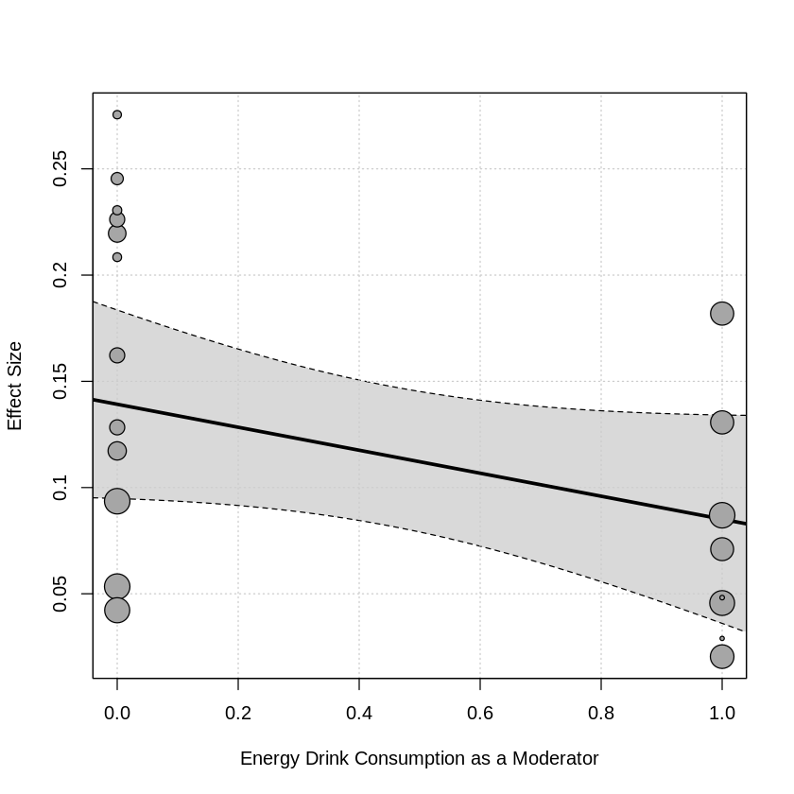
Figure 3. Moderating Effect of Energy Drink Consumption of Relationship Between ADHD Symptomatology and Caffeinated Beverage Consumption.
Discussion:
After pooling 20 effect sizes from 14 studies assessing the association between ADHD symptomatology and caffeinated beverage consumption, a significant positive association was found. This is consistent with the existing studies identifying associations between ADHD symptomatology and other forms of stimulant use such as cocaine, and cigarettes, as well as sugary and soft drink beverage consumption (Farsad-Naeimi 2020; Kollins 2005; Oliva 2011). It is important to note that because studies included in this meta-analysis were cross-sectional, directionality of the relationship between ADHD symptomatology and caffeinated beverages cannot be inferred. In our model, significant heterogeneity between studies was identified, highlighting a need to interpret the results of the pooled effect size with caution. There was also indication of potential publication bias, with smaller studies tending to report larger effect sizes. Meta-regression analyses were performed to explore potential moderating variables causing this heterogeneity and found no significant moderators in the relationship between ADHD symptomatology and caffeinated beverage consumption, although the largest effect size existed for proportion of male participants, which had a positive yet insignificant moderating effect on the relationship between caffeinated beverage consumption and ADHD symptomatology. Future research should explore the directionality of the overall relationship between ADHD symptomatology and caffeinated beverage consumption, and other potential moderators.
Conclusion:
This meta-analysis analyzed cross-sectional studies reporting the relationship between caffeinated beverage consumption and ADHD symptomatology. After pooling effect sizes using the metafor package in R, a positive and significant correlation between ADHD symptomatology and caffeinated beverage consumption was found. Meta-regressions were run on potential moderators, resulting in no significant moderating variables identified. Due to the significant amount of heterogeneity in effect sizes reported between studies and potential publication bias indicated, caution should be used when interpreting results.

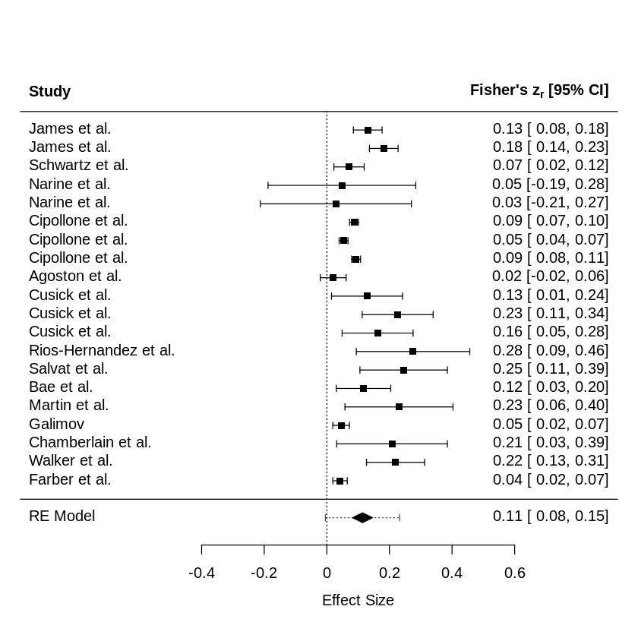
Figure 4. Forest plot to visualize the individual effect sizes.
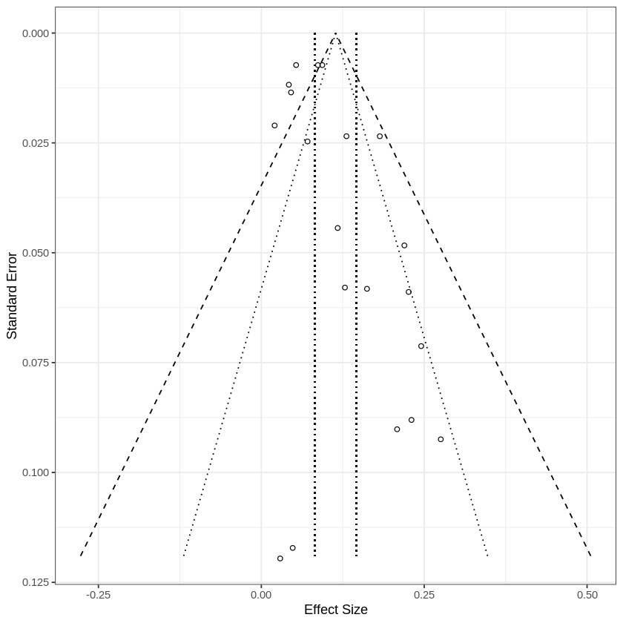
Figure 5. Funnel plot to visualize potential publication bias.
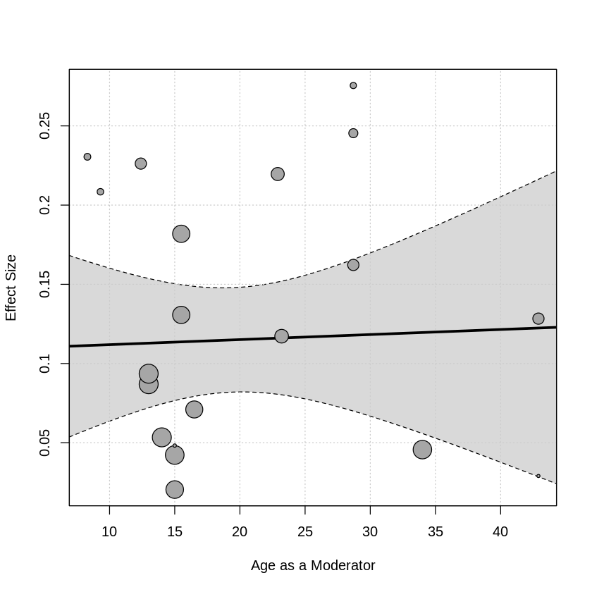
Figure 6. Regression Plot of Age as a Moderator.
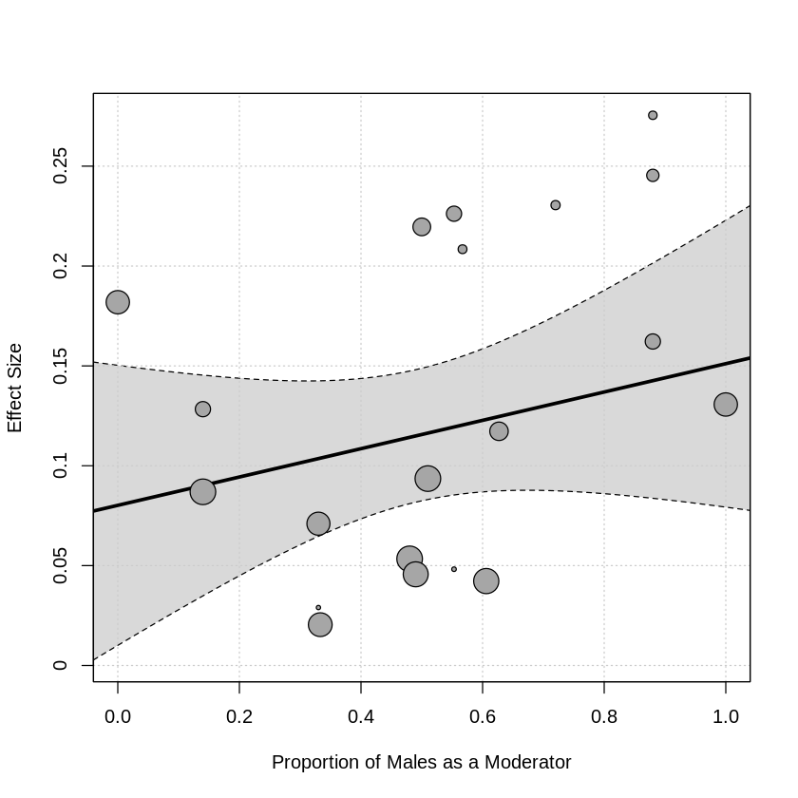
Figure 7. Regression Plot of the Proportion of Males as a Moderator.

References:
- Ágoston, C., Urbán, R., Horváth, Z., van den Brink, W., & Demetrovics, Z. (2022). Self-Medication of ADHD Symptoms: Does Caffeine Have a Role?. Frontiers in Psychiatry, 13, 813545.
- Bae, E. J., Kim, E. B., Choi, B. R., Won, S. H., Kim, J. H., Kim, S. M., ... & Lim, M. H. (2019). The relationships between addiction to highly caffeinated drinks, burnout, and attention-deficit/hyperactivity disorder. Journal of the Korean Academy of Child and Adolescent Psychiatry, 30(4), 153.
- Chamberlain, S. R., Derbyshire, K., Leppink, E., & Grant, J. E. (2015). Impact of ADHD symptoms on clinical and cognitive aspects of problem gambling. Comprehensive Psychiatry, 57, 51-57.
- Cipollone, G., Gehrman, P., Manni, C., Pallucchini, A., Maremmani, A. G., Palagini, L., ... & Maremmani, I. (2020). Exploring the role of caffeine use in adult-ADHD symptom severity of US army soldiers. Journal of Clinical Medicine, 9(11), 3788.
- Cusick, C. N., Langberg, J. M., Breaux, R., Green, C. D., & Becker, S. P. (2020). Caffeine use and associations with sleep in adolescents with and without ADHD. Journal of pediatric psychology, 45(6), 643-653.
- Faraone, S. V., & Buitelaar, J. (2010). Comparing the efficacy of stimulants for ADHD in children and adolescents using meta-analysis. European child & adolescent psychiatry, 19(4), 353-364.
- Farber, J., Dikdan, S., Ruge, M., Johnson, D., & Shipon, D. (2024). Relationship Between Caffeine Consumption and Young Athletes’ Comorbidities, Exercise-Related Symptoms, and Baseline Electrocardiogram. Sports Health, 16(3), 448-456.
- Farsad-Naeimi, A., Asjodi, F., Omidian, M., Askari, M., Nouri, M., Pizarro, A. B., & Daneshzad, E. (2020). Sugar consumption, sugar sweetened beverages and attention deficit hyperactivity disorder: a systematic review and meta-analysis. Complementary Therapies in Medicine, 53, 102512.
- Galimov, A. (2021). Energy Drink Consumption, Substance Use and Attention-Deficit/Hyperactivity Disorder Among Adolescents (Doctoral dissertation, University of Southern California).
- James, J. E., Kristjansson, A. L., & Sigfusdottir, I. D. (2015). A gender-specific analysis of adolescent dietary caffeine, alcohol consumption, anger, and violent behavior. Substance use & misuse, 50(2), 257-267.
- Martin, C. A., Cook, C., Woodring, J. H., Burkhardt, G., Guenthner, G., Omar, H. A., & Kelly, T. H. (2008). Caffeine use: association with nicotine use, aggression, and other psychopathology in psychiatric and pediatric outpatient adolescents. The Scientific World Journal, 8, 512-516.
- Mészáros, A., Czobor, P., Bálint, S., Komlósi, S., Simon, V., & Bitter, I. (2009). Pharmacotherapy of adult attention deficit hyperactivity disorder (ADHD): a meta-analysis. The International Journal of Neuropsychopharmacology, 12(8), 1137-1147.
- Nanda, A., Janga, L. S. N., Sambe, H. G., Yasir, M., Man, R. K., Gogikar, A., & Mohammed, L. (2023). Adverse Effects of Stimulant Interventions for Attention Deficit Hyperactivity Disorder (ADHD): A Comprehensive Systematic Review. Cureus, 15(9).
- Narine, C., Weller, J., & Mathieson, K. (2021). Energy Drink Use in Adolescents With and Without ADHD: Trends and Influences. Innovations in Clinical Neuroscience, 18(4-6), 28.
- Oliva, F., Mangiapane, C., Nibbio, G., Berchialla, P., Colombi, N., & Vigna-Taglianti, F. D. (2021). Prevalence of cocaine use and cocaine use disorder among adult patients with attention-deficit/hyperactivity disorder: A systematic review and meta-analysis. Journal of Psychiatric Research, 143, 587-598.
- Reichenberg, L. W., & Seligman, L. (2016). Selecting effective treatments: A comprehensive, systematic guide to treating mental disorders. John Wiley & Sons.
- Ríos-Hernández, A., Alda, J. A., Farran-Codina, A., Ferreira-García, E., & Izquierdo-Pulido, M. (2017). The Mediterranean diet and ADHD in children and adolescents. Pediatrics, 139(2).
- Salvat, H., Mohammadi, M. N., Molavi, P., Mostafavi, S. A., Rostami, R., & Salehinejad, M. A. (2022). Nutrient intake, dietary patterns, and anthropometric variables of children with ADHD in comparison to healthy controls: a case-control study. BMC pediatrics, 22(1), 1-9.
- Schwartz, D. L., Gilstad-Hayden, K., Carroll-Scott, A., Grilo, S. A., McCaslin, C., Schwartz, M., & Ickovics, J. R. (2015). Energy drinks and youth self-reported hyperactivity/inattention symptoms. Academic pediatrics, 15(3), 297-304.
- Sayal, K., Prasad, V., Daley, D., Ford, T., & Coghill, D. (2018). ADHD in children and young people: prevalence, care pathways, and service provision. The Lancet Psychiatry, 5(2), 175-186.
- Vázquez, J.C.; Martin de la Torre, O.; López Palomé, J.; Redolar-Ripoll, D. Effects of Caffeine Consumption on Attention Deficit Hyperactivity Disorder (ADHD) Treatment: A Systematic Review of Animal Studies. Nutrients 2022, 14, 739.
- Walker, L. R., Abraham, A. A., & Tercyak, K. P. (2010). Adolescent caffeine use, ADHD, and cigarette smoking. Children's Health Care, 39(1), 73-90.

